**CREATE DATABASE superstore;**

**USE superstore;**

**Task 1:- Understanding the Data**

**1.** About Data :

The data is about all records of the Superstore. The Table wise information of data are given below:

1. cust_dimen: Details of all the customers

Customer_Name (TEXT): Name of the customer

Province (TEXT): Province of the customer

Region (TEXT): Region of the customer

Customer_Segment (TEXT): Segment of the customer

Cust_id (TEXT): Unique Customer ID

2. market_fact: Details of every order item sold

Ord_id (TEXT): Order ID

Prod_id (TEXT): Prod ID

Ship_id (TEXT): Shipment ID

Cust_id (TEXT): Customer ID

Sales (DOUBLE): Sales from the Item sold

Discount (DOUBLE): Discount on the Item sold

Order_Quantity (INT): Order Quantity of the Item sold

Profit (DOUBLE): Profit from the Item sold

Shipping_Cost (DOUBLE): Shipping Cost of the Item sold

Product_Base_Margin (DOUBLE): Product Base Margin on the Item sold

3. orders_dimen: Details of every order placed

Order_ID (INT): Order ID

Order_Date (TEXT): Order Date

Order_Priority (TEXT): Priority of the Order

Ord_id (TEXT): Unique Order ID

4. prod_dimen: Details of product category and sub-category

Product_Category (TEXT): Product Category

Product_Sub_Category (TEXT): Product Sub Category

Prod_id (TEXT): Unique Product ID

5. shipping_dimen: Details of shipping of orders

Order_ID (INT): Order ID

Ship_Mode (TEXT): Shipping Mode

Ship_Date (TEXT): Shipping Date

Ship_id (TEXT): Unique Shipment ID

**2.** Relationships and List of Primary key and Foreign Keys:

Relationship of the data:

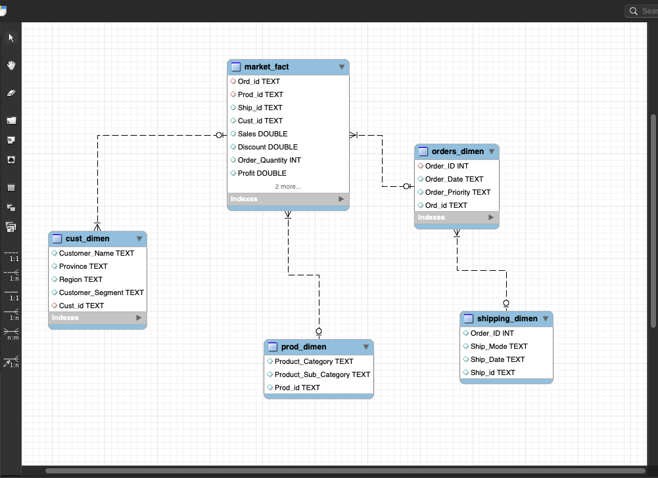

Table wise List of Keys:

1. Cust_dimen:

Primary Key: Cust_id

Foreign Key: N/A

2. market_fact:

Primary Key: N/A

Foreign Key: Ord_id, Prod_id, Ship_id, Cust_id

3. orders_dimen:

Primary Key: Ord_id

Foreign Key: N/A

4. prod_dimen:

Primary Key: Prod_id, Product_Sub_Category

Foreign Key: N/A

5. shipping_dimen:

Primary Key: Ship_id

Foreign Key: N/A

**Task 2:- Basic & Advanced Analysis**

**/*1. Write a query to display the Customer_Name and Customer Segment using alias name “Customer Name", "Customer Segment" from table Cust_dimen.*/**

SELECT Customer_Name AS "Customer Name" , Customer_Segment

AS "Customer Segement"

FROM cust_dimen;

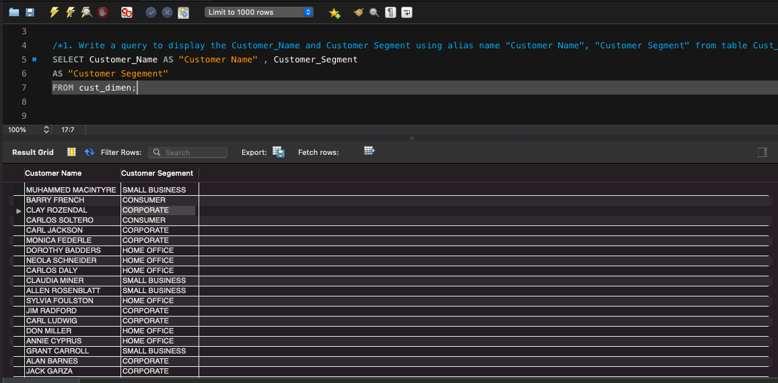

**/*2. Write a query to find all the details of the customer from the table cust_dimen order by desc.*/**

SELECT *

FROM cust_dimen

ORDER BY customer_name desc;

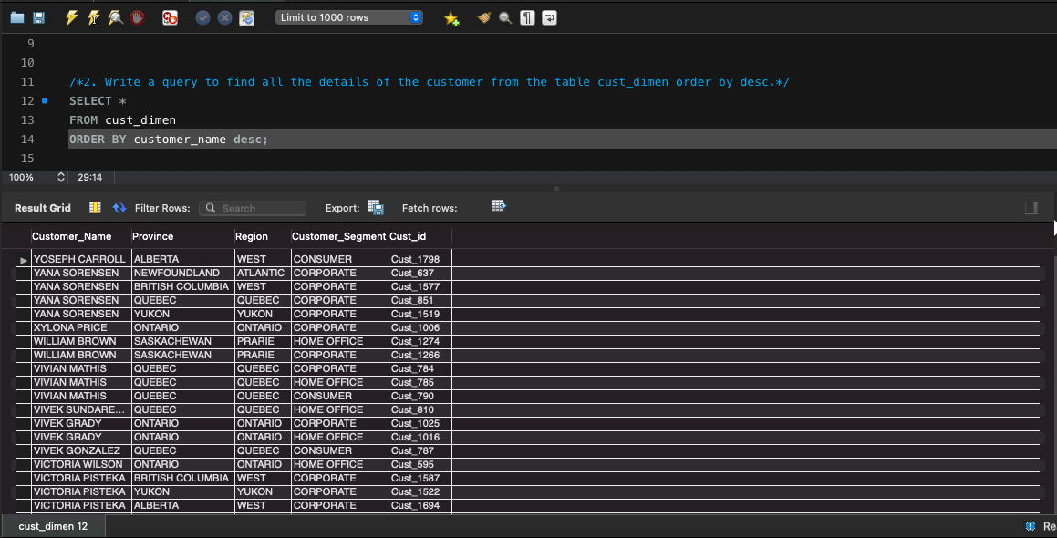

SELECT *

FROM cust_dimen

ORDER BY cust_id desc;

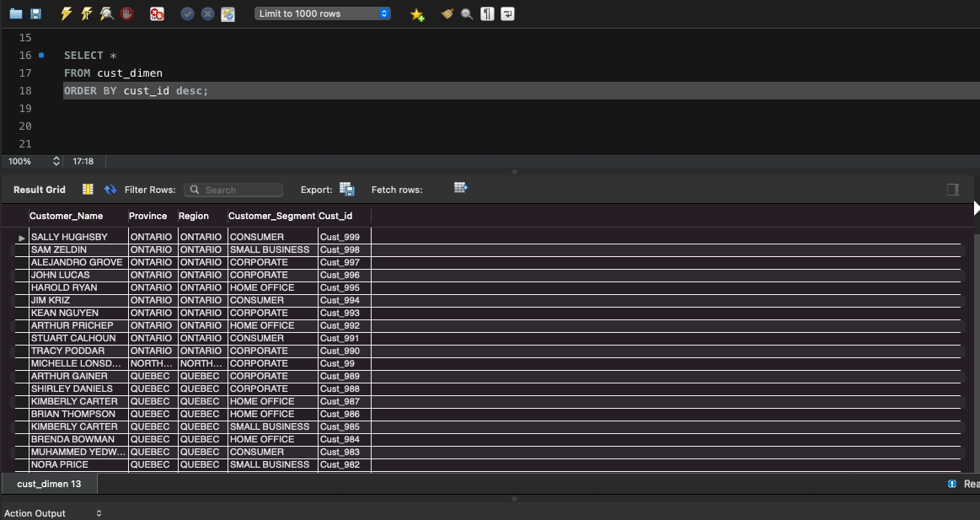

**/*3. Write a query to get the Order ID, Order date from table orders_dimen where ‘Order Priority’ is high.*/**

SELECT order_id AS "Order ID", order_date AS "Order Date"

FROM orders_dimen

WHERE order_priority = 'HIGH';

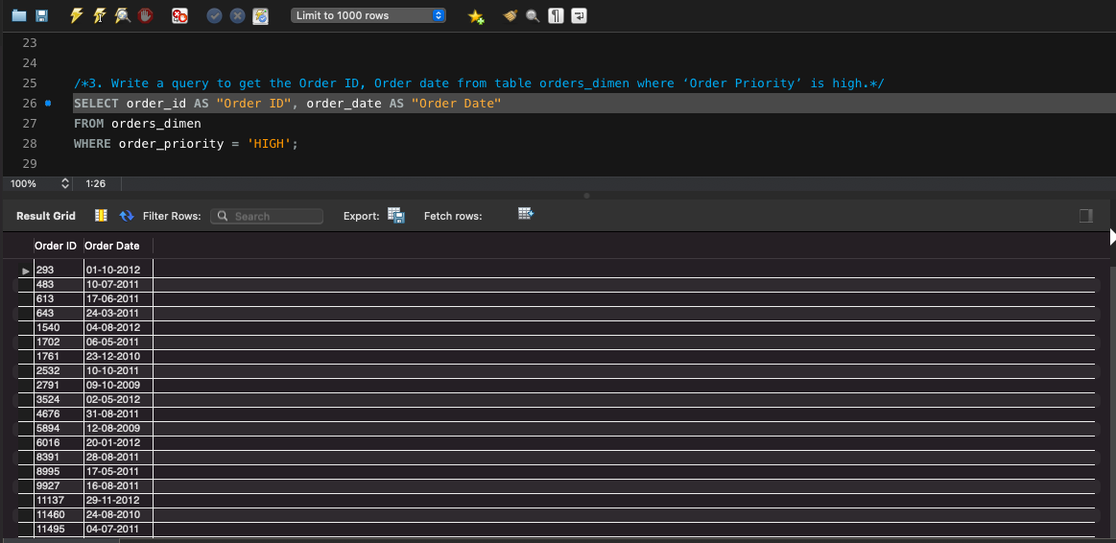

**/*4. Find the total and the average sales (display total_sales and avg_sales) */**

SELECT sum(sales) AS 'Total_Sales', avg(sales) AS 'Avg_Sales'

FROM market_fact;

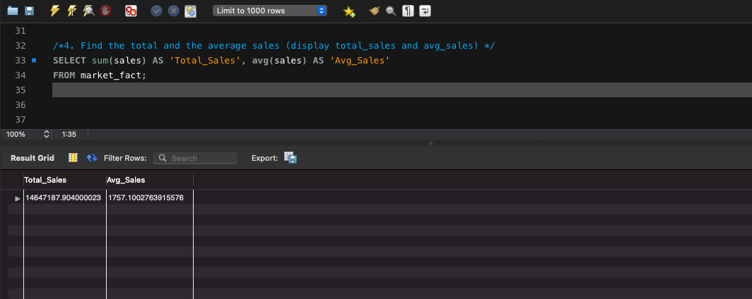

**/*5. Write a query to get the maximum and minimum sales from maket_fact table.*/**

SELECT max(sales) AS 'Max_Sales', min(sales) AS 'Min_Sales'

FROM market_fact;

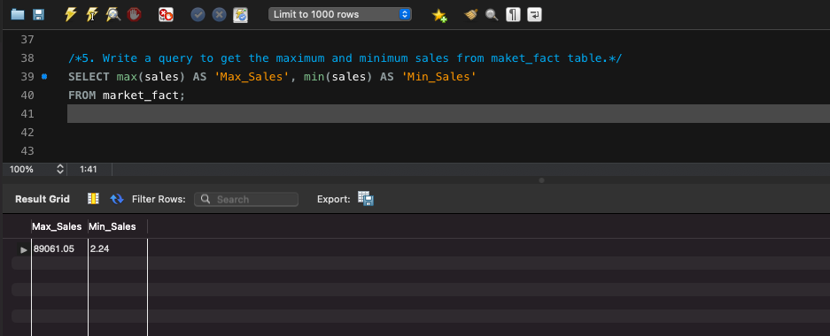

**/*6. Display the number of customers in each region in decreasing order of**

**no_of_customers. The result should contain columns Region, no_of_customers.*/**

SELECT COUNT(region) AS no_of_customer, region

FROM cust_dimen

GROUP BY region

order by no_of_customer desc;

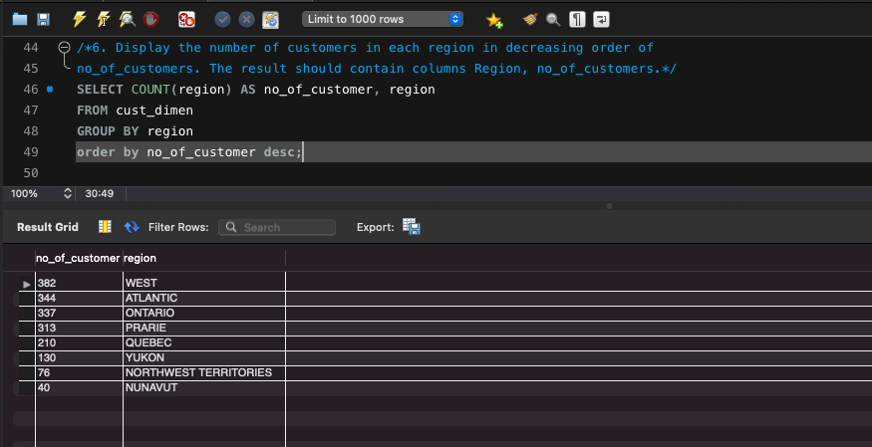

**/*7. Find the region having maximum customers (display the region name and max(no_of_customers)*/**

SELECT COUNT(region) AS no_of_customer, region

FROM cust_dimen

GROUP BY region

order by no_of_customer desc LIMIT 1;

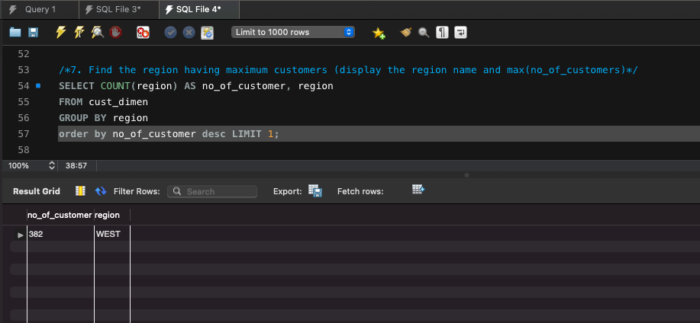

**/*8. Find all the customers from Atlantic region who have ever purchased ‘TABLES’**

**and the number of tables purchased (display the customer name, no_of_tables purchased) */**

SELECT c.Customer_name, count(m.Prod_id) AS 'no_of_tables'

FROM cust_dimen c join market_fact m ON m.Cust_id = c.Cust_id join prod_dimen p

ON p.Prod_id = m.Prod_id

WHERE c.Region = 'ATLANTIC' AND p.Product_Sub_Category = 'TABlES'

GROUP BY c.Customer_name;

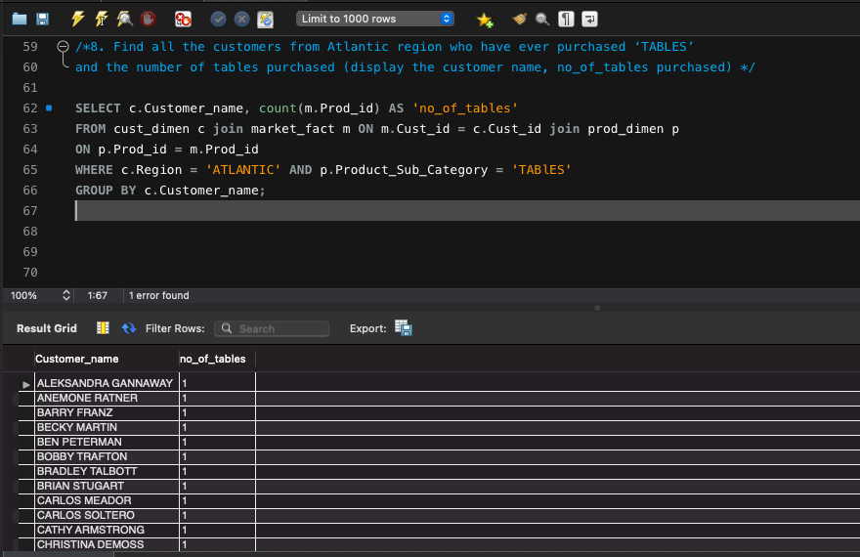

**/*9. Find all the customers from Ontario province who own Small Business. (display**

**the customer name, no of small business owners)*/**

SELECT customer_name, count(customer_sagement='SMALL BUSINESS') AS 'number of small business'

FROM cust_dimen

WHERE province = 'Ontario'

GROUP BY customer_name

ORDER BY count(customer_sagement='SMALL BUSINESS') desc;

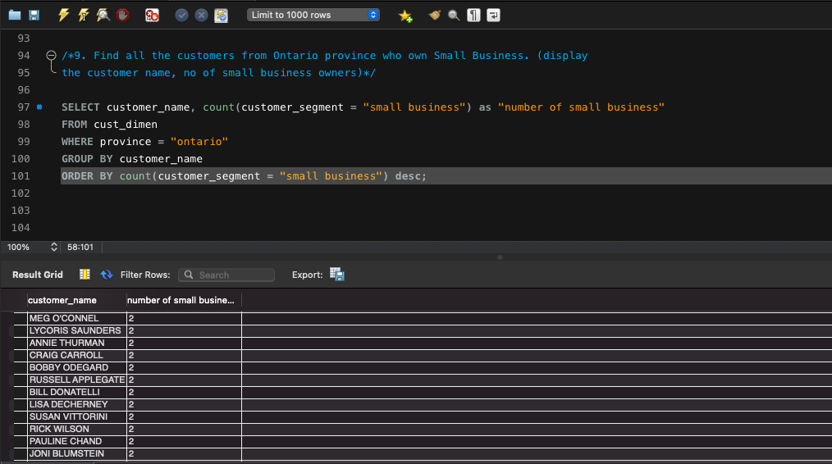

**/*10. Find the number and id of products sold in decreasing order of products sold**

**(display product id, no_of_products sold)*/**

SELECT prod_id AS 'Product ID', order_quantity AS 'no_of_product sold'

FROM market_fact

ORDER by order_quantity DESC;

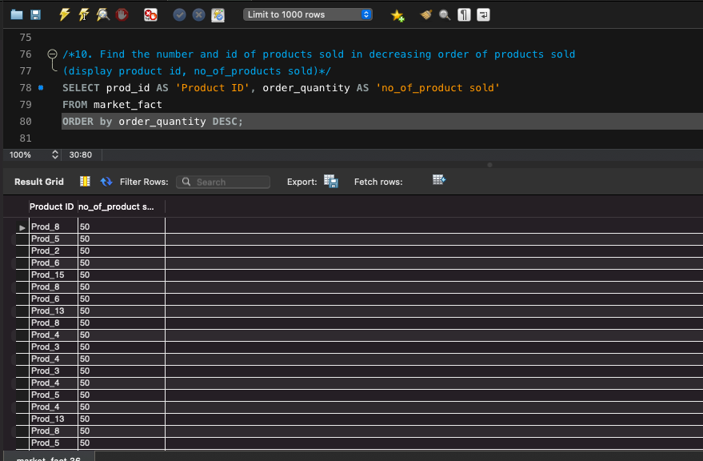

**/*11. Display product Id and product sub category whose produt category belongs to**

**Furniture and Technlogy. The result should contain columns product id, product**

**sub category.*/**

SELECT prod_id AS 'Product ID', product_sub_category AS 'Product sub-category'

FROM prod_dimen

WHERE product_category = 'FURNITURE' OR product_category = 'TECHNOLOGY';

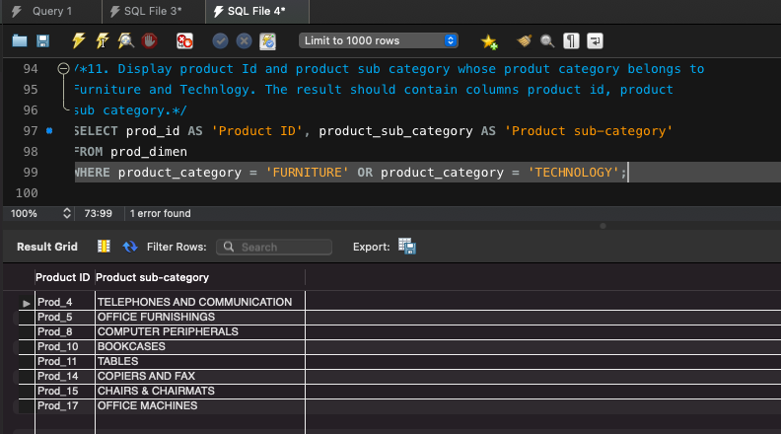

**/*12. Display the product categories in descending order of profits (display the product**

**category wise profits i.e. product_category, profits)?*/**

SELECT prod_dimen.product_category, market_fact.profit

FROM market_fact

LEFT JOIN prod_dimen ON

market_fact.prod_id = prod_dimen.prod_id

ORDER BY market_fact.profit DESC;

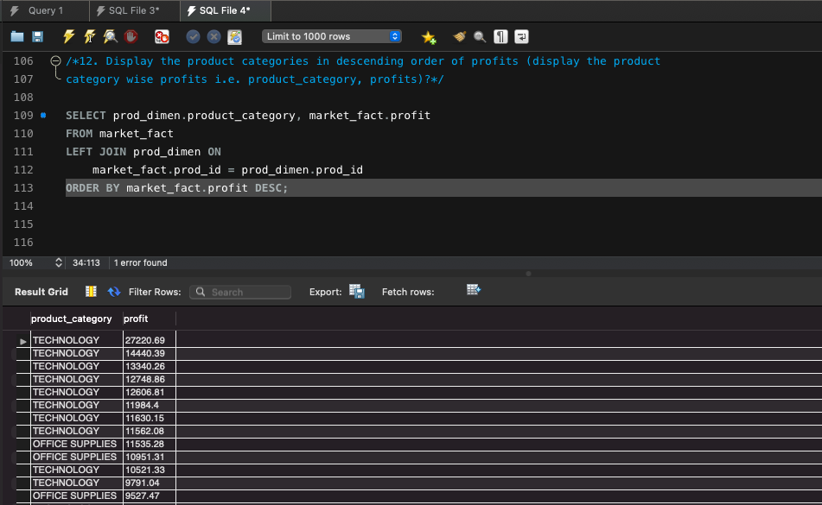

**/*13. Display the product category, product sub-category and the profit within each**

**subcategory in three columns. */**

SELECT prod_dimen.product_category, prod_dimen.product_sub_category, sum(market_fact.profit) AS profit

FROM market_fact

LEFT JOIN prod_dimen ON

market_fact.prod_id = prod_dimen.prod_id

GROUP by product_category, product_sub_category;

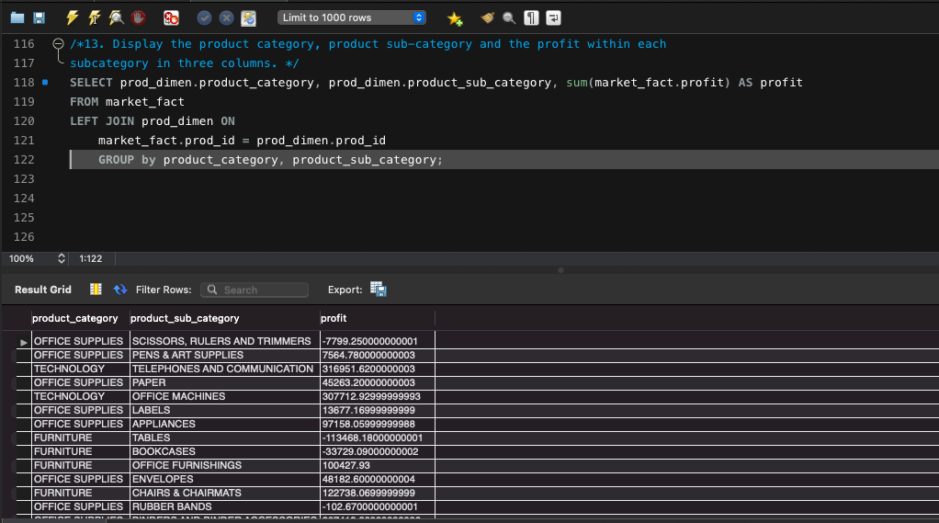

**/*14. Display the order date, order quantity and the sales for the order.*/**

SELECT orders_dimen.order_date, market_fact.order_quantity, market_fact.sales

FROM orders_dimen

LEFT JOIN market_fact ON

orders_dimen.ord_id = market_fact.ord_id;

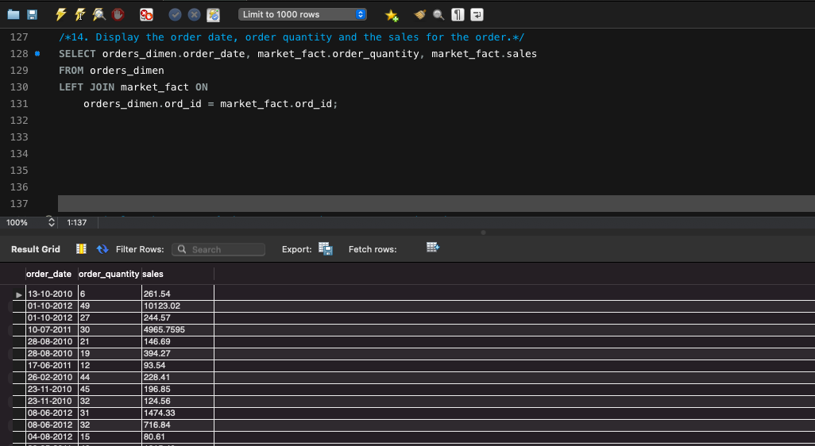

**/*15. Display the names of the customers whose name contains the**

**i) Second letter as ‘R’**

**ii) Fourth letter as ‘D’ */**

SELECT customer_name

FROM cust_dimen

WHERE customer_name LIKE '_R_D%'

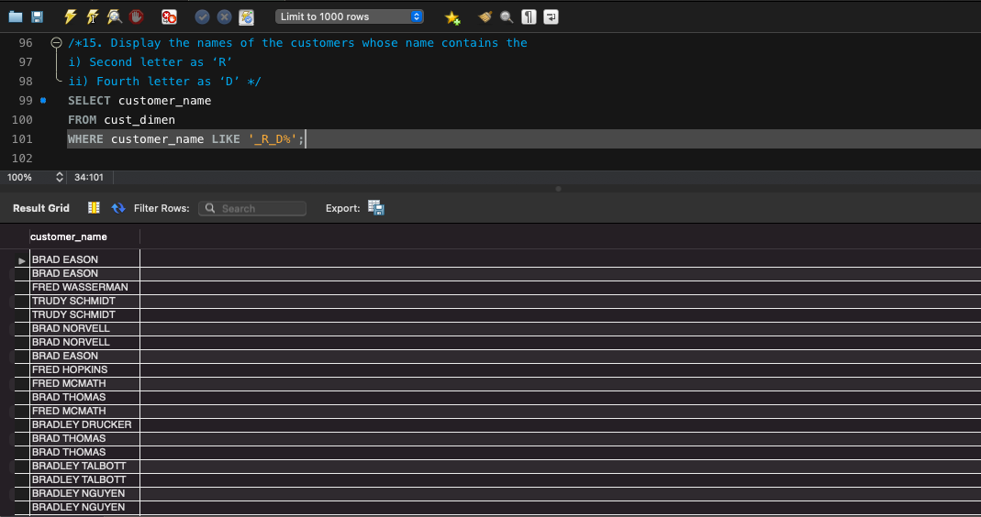

**/*16. Write a SQL query to make a list with Cust_Id, Sales, Customer Name and**

**their region where sales are between 1000 and 5000.*/**

SELECT cust_dimen.cust_id, market_fact.sales, cust_dimen.customer_name

FROM cust_dimen

LEFT JOIN market_fact ON

cust_dimen.cust_id = market_fact.cust_id

WHERE market_fact.sales BETWEEN 1000 AND 5000;

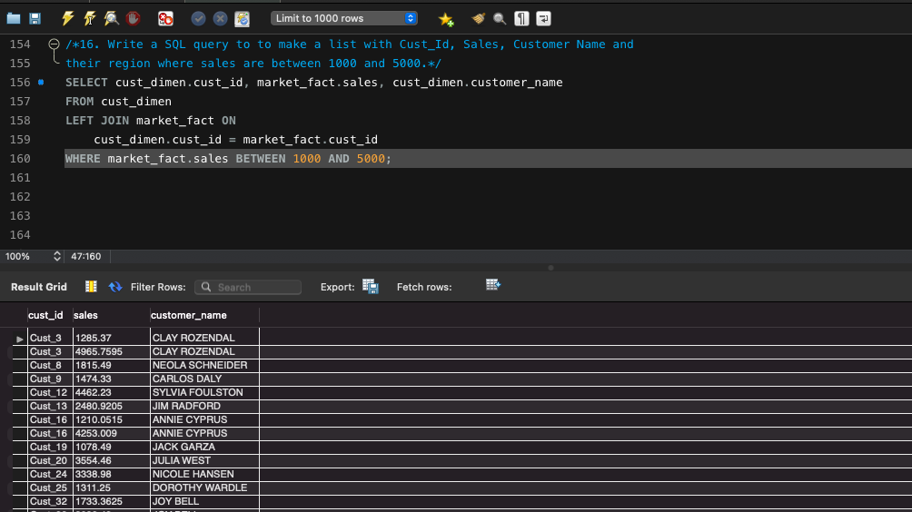

**/*17. Write a SQL query to find the 3rd highest sales.*/**

SELECT sales

FROM (SELECT sales

FROM market_fact

ORDER BY sales DESC limit 3) AS comp

ORDER BY sales LIMIT 1;

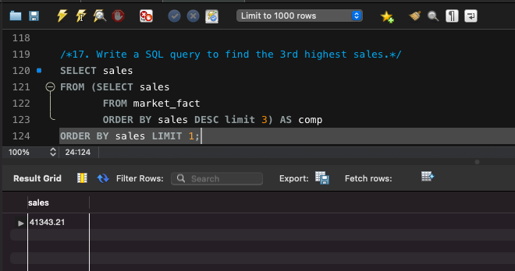

**/*18. Where is the least profitable product-subcategory shipped the most? For the least**

**profitable product sub-category, display the region-wise no_of_shipments and the**

**profit made in each region in decreasing order of profits (i.e. region, no_of_shipments, profit_in_each_region)**

**→Note: You can hardcode the name of the least profitable product subcategory */**

SELECT c.Region as "Region",count(m.Ship_id) as "No of Shipments",

round(sum(m.Profit),2) as "Profit in each region"

FROM market_fact m

join cust_dimen c on m.Cust_id = c.Cust_id

join prod_dimen p on m.Prod_id = p.Prod_id

WHERE Product_Sub_Category = (

SELECT p.Product_Sub_Category

FROM market_fact m

join prod_dimen p on m.Prod_id = p.Prod_id

GROUP BY Product_Sub_Category

ORDER BY sum(m.Profit)

LIMIT 1)

GROUP BY c.Region

ORDER BY sum(m.Profit);

